CBSE Maths notes, CBSE physics notes, CBSE chemistry notes

Important Questions for Class 12 Computer Science (Python) – Structured Query Language

Important Questions for Class 12 Computer Science (Python) – Structured Query Language

**Short Answer Type Questions**

**Question 1:**Write queries for (i) to (iv) and find ouputs for SQL queries (v) to (viii), which are based on the  tables.

**Table : VEHICLE** 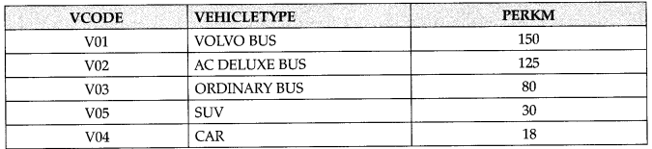  
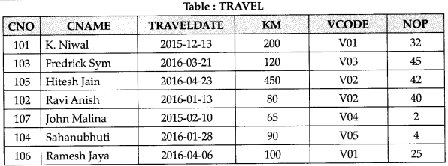

**Note:**

* PERKS is Freight Charges per kilometer.
* Km is kilometers Travelled
* NOP is number of passangers travelled in vechicle.

1. To display CNO, CNAME, TRAVELDATE from the table TRAVEL in descending order of CNO.
2. To display the CNAME of all customers from the table TRAVEL who are travelling by vechicle with code Vo1or Vo2
3. To display the CNO and CNAME of those customers from the table TRAVEL who travelled between ‘2015-12­31’ and ‘2015-05-01’.
4. To display all the details from table TRAVEL for the customers, who have travel distacne more than 120 KM in ascending order of NOE
5. SELECT COUNT (*), VCODE FROM TRAVEL GROUP BY VCODE HAVING COUNT (*) > 1;
6. SELECT DISTINCT VCODE FROM TRAVEL :
7. SELECT A.VCODE, CNAME, VEHICLETYPE FROM TRAVEL A, VEHICLE B WHERE A. VCODE = B. VCODE and KM < 90;
8. SELECT CNAME, KM*PERKM FROM TRAVEL A, VEHICLE B WHERE A.VCODE = B.VCODE AND A. VCODE ‘V05’;

**Answer:**  
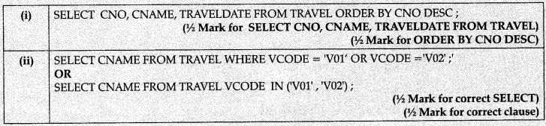  
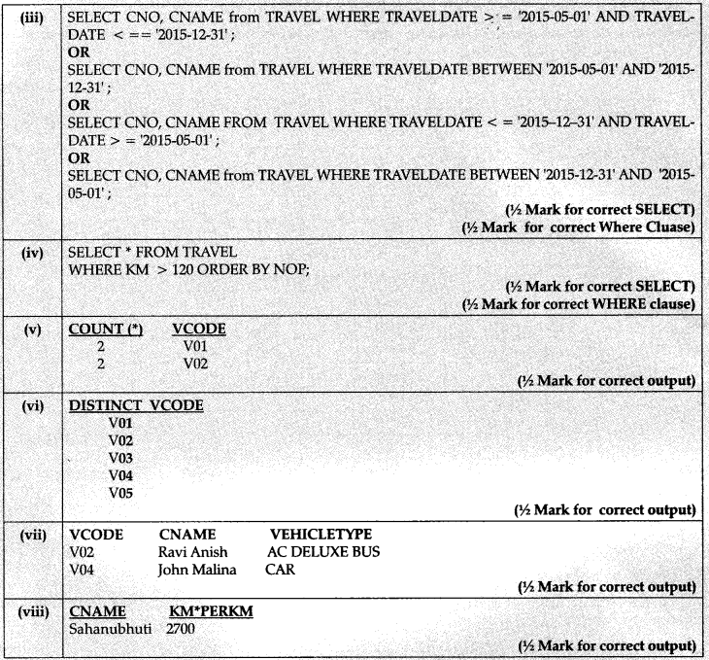

**Question 2:**  
Consider the following tables SCHOOL and ADMIN and answer this question :  
Give the output the following SQL queries :

1. Select Designation Count (*) From Admin Group By Designation Having Count (*) <2;
2. SELECT max (EXPERIENCE) FROM SCH­OOL;
3. SELECT TEACHER FROM SCHOOL WHERE EXPERIENCE >12 ORDER BY TEACHER;
4. SELECT COUNT (*), GENDER FROM AD­MIN GROUP BY GENDER;

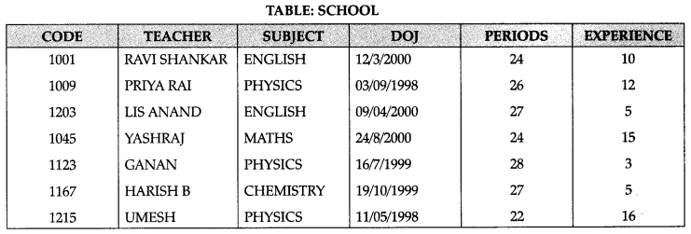

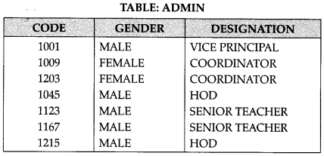

**Answer:**  
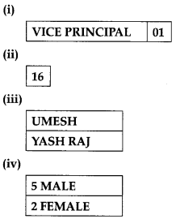

**Question 3:**Write SQL qureries for (i) to (iv) and find outputs for SQL queries (v) to (viii), which are based on the tables TRANSPORT and TRIE  
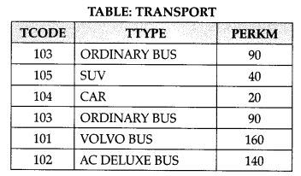

**Note:**

* PERKS is Freight Charages per kilometer
* TTYPE is Transport Vehicle Type

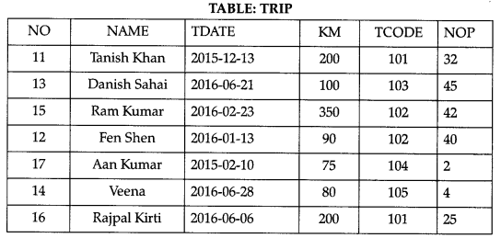

Note:

* NO is Driver Number
* KM is Kilometer travelled
* NOP is number of travellers travelled in vehicle
* TDATE is Trip Date

1. To display NO, NAME, TDATE from the table TRIP in descending order of NO.
2. To display the NAME of the drivers from the table TRIP who are traveling by transport vehicle with code 101 or 103.
3. To display the NO and NAME of those drivers from the table TRIP who travelled between ‘2015-02-10’ and ‘2015-04-01’.
4. To display all the details from table TRIP in which the distance travelled is more than 100 KM in ascending order of NOP
5. SELECT COUNT (*), TCODE From TRIP  
   GROUP BY TCODE HAVNING COUnT (*) > 1;
6. SELECT DISTINCT TCODE from TRIP;
7. SELECT A.TCODE, NAME, TTYPE  
   FROM TRIP A, TRANSPORT B  
   WHERE A. TCODE = B. TCODE AND KM < 90;
8. SELECT NAME, KM *PERKM  
   FROM TRIP A, TRANSPORT B  
   WHERE A. TCODE = B. TCODE AND A. TCODE = 105′;

**Answer:**

1. SELECT NO, NAME, TDATE FROM TRIP ORDER BY NO;
2. SELECT NAME FROM TRIP  
   WHERE TCODE = 101 OR TCODE = 103;
3. SELECT NO AND NAME FROM TRIP  
   WHERE ‘2015-02-10’ < TDATE < ‘2015-04-01’;
4. SELECT NO, NAME, TDATE, KM, TCODE FROM TRIP  
   WHERE KM >100 ORDER BY NOP;
5. TO DISPLAY THE MORE THAN ONE COUNT OF TCODE FROM THE TABLE TRIP
6. TO DISPALY SEPERATE TCODE OF TABLE TRIP
7. TO DISPAY THE NAME AND CODE OF THOSE TRANS PORTERS, WHO HAVE TRAVELLED MORE THAN 90 KMS.
8. TO DISPLAY THE NAME AND EXPENDITARE OF A TRANSPORTER WHO HAVE TCODE AS 105.

**Question 4:**  
Write SQL query to add a column total price with datatype numeric and size 10, 2 in a table product.  
**Answer:**  
ALTER TABLE PRODUCT ADD TOTAL PRICE NUMBER (10,2).

**Question 5:**  
Sonal needs to display name of teachers, who have “0” as the third character in their name. She wrote the following query.  
SELECT NAME FROM TEACHER WHERE NAME = “$$0?”;  
But the query is’nt producing the result. Identify the problem.  
**Answer:**  
The wildcards are incorrect. The corrected query is SELECT NAME FROM TEACHER WHERE NAME LIKE ‘_ _0%’.

**Question 6:**  
Deepika wants to remove all rows from the table BANK. But he needs to maintain the structure of the table. Which command is used to implement the same?  
**Answer:**  
DELETE FROM BANK.

**Question 7:**  
While creating table ‘customer’, Rahul forgot to add column ‘price’. Which command is used to add new column in the table. Write the command to implement the same.  
**Answer:**  
ALTER TABLE CUSTOMER ADD PRICE NUMBER (10, 2).

**Question 8:**  
What is the use of wildcard  
**Answer:**  
The wildcard operators are used with the LIKE operator to search a value similar to a specific pattern in a column. There are 2 wildcard operators.  
% – represents 0,1 or many characters – – represents a single number or character

**Question 9:**  
Differentiate between DELETE and DROP table commands ?  
**Answer:**  
DELETE command is used to remove infor¬mation from a particular row or rows. If used without condition, it will delete all row information but not the structure of the table. It is a DML command.  
DROP table command is used to remove the entire structure of the table and information. It is a DDL command

**Long Answer Type Questions**

**Question 1:**  
Write SQL commands for the queries (i) to (iv) and output for (v) & (viii) based on a table COMPANY and CUSTOMER.  
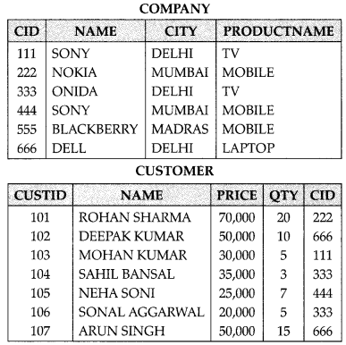

1. To display those company name which are having prize less than 30000.
2. To display the name of the companies in reverse alphabetical order.
3. To increase the prize by 1000 for those customer whose name starts with „S?
4. To add one more column totalprice with decimal] 10,2) to the table customer
5. SELECT     COUNT(*)  , CITY     FROM COMPANY GROUP BY CITY;
6. SELECT MIN(PRICE), MAX(PRICE) FROM CUSTOMER WHERE QTY>10;
7. SELECT AVG(QTY) FROM CUSTOMER WHERE NAME LIKE “%r%;
8. SELECT PRODUCTNAME,CITY, PRICE  
   FROM COMPANY, CUSTOMER WHERE  
   COMPANY. CID=CUSTOMER.CID AND  
   PRODUCTNAME=”MOBILE”;

**Answer:**

1. SELECT NAME FROM COMPANY WHERE COMPANY.CID=CUSTOMER. CID AND  
   PRICE < 30000;
2. SELECT NAME FROM COMPANY ORDER BY NAME DESC;
3. UPDATE CUSTOMER  
   SET PRICE = PRICE + 1000  
   WHERE NAME LIKE ‘S%’;
4. ALTER TABLE CUSTOMER  
   ADD TOTALPRICE DECIMAL(10,2);
5. 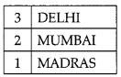
6. 50000,70000
7. 11
8. important-questions-for-class-12-computer-science-python-structured-query-language-12

**Question 2:**  
Consider the following tables SCHOOL and ADMIN and answer this question :  
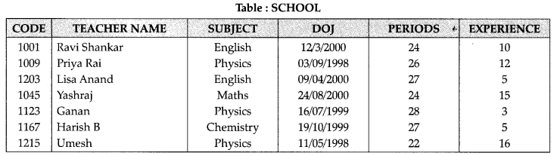  
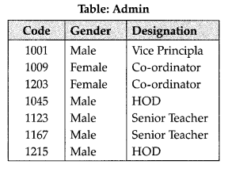

Write SQL statements for the following:

1. To display TEACHERNAME, PERIODS of all teachers whose periods are more than 25.
2. To display all the information from the table SCHOOL in descending order of experience.
3. To display DESIGNATION without dupli¬cate entries from the table ADMIN.
4. To display TEACHERNAME, CODE and corresponding DESIGNATION from tables SCHOOL and ADMIN of Male teachers.

**Answer:**

1. SELECT TEACHERNAME, PERIODS  
   FROM SCHOOL WHERE PERIODS>25:
2. SELECT * FROM SCHOOL;
3. SELECT DISTINCT DESIGNATION FROM ADMIN;
4. SELECT TEACHERNAME.CODE  
   DESIGNATION FROM  
   SCHOOL.CODE = ADMIN.CODE  
   WHERE GENDER = MALE;

**Question 3:**  
Write SQL commands for the queries (i) to (iv) and output for (v) to (viii) based on the tables Watches’ and Sale given below.  
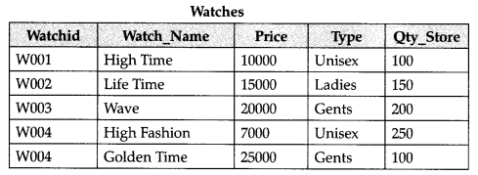  
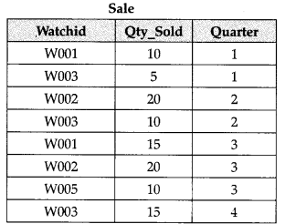

1. TO DISPLAY ALL THE DETAILS OF THOSE WATCHES WHOSE NAME ENDS WITH ‘TIME’
2. TO DISPLAY WATCH’S NAME AND PRICE OF THOSE WATCHES WHICH HAVE PRICE RANGE IN BE-TWEEN 5000-15000.
3. TO DISPLAY TOTAL QUANTITY IN STORE OF UNISEX TYPE WATCHES.
4. TO DISPLAY WATCH NAME AND THEIR QUANTITY SOLD IN FIRST QUARTER;
5. SELECT MAX (PRICE), MIN(QTY_STORE) FROM WATCHES;
6. SELECT QUARTER, SUM(QTY SOLD) FROM SALE GROUP BY QUARTER;
7. SELECT WATCH_NAME, PRICE, TYPE FROM WATCHES W, SALE S WHERE W. WAT£H1D!=S.WATCHID; (viii) SELECT WATCH_NAME, QTYSTORE, SUM (QTY_SOLD), QTY_STORESUM (QTYSOLD) “STOCK” FROM WATCHES W, SALE S WHERE W. WATCHID = S.WATCHID GROUP BY S.WATCHID;

**Answer:**

1. SELECT * FROM WATCHES WHERE WATCH_NAME LIKE ‘%TIME’  
   (Vi mark for SELECT query) (Vi mark for where clause)
2. SELECT WATCH_NAME, PRICE WATCH WHERE PRICE BETWEEN 5000 AND 15000;  
   (Vi mark for SELECT query) (Vz mark for where clause)
3. SELECT SUM (QTY STORE) FROM WATCHES WHERE TYPE LIKE ‘UNISEX’;  
   (Vz mark for SELECT query) (Vi mark for where clause)
4. SELECT WATCHNAME, QTY SOLD FROM WATCHES W,SALE S WHERE W. WATCHID = S. WATCHID  
   AND QUARTER = 1;  
   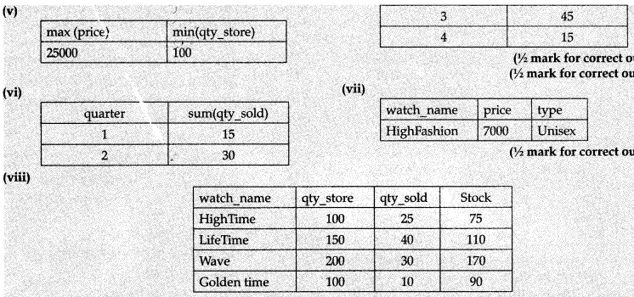

**Question 4:**  
Answer the questions (a) and (b) on the basis of the following tables SHOP and ACCESSORIES.  
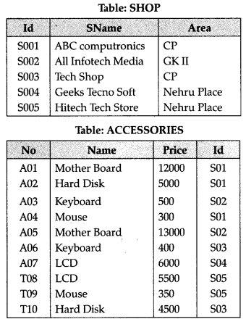

(a) Write the SQL queries:

1. To display Name and Price of all the Accessories in ascending order of their Price.
2. To display Id and SName of all Shop located in Nehru Place.
3. To display Minimum and Maximum Price of each Name of Accessories.
4. To display Name, Price of all Accessories and their respective SName where they are available.

(b) Write the output of the following SQL

1. SELECT DISTINCT NAME FROM ACCESSORIES WHERE PRICE> =5000;
2. SELECT AREA, COUNT(*) FROM SHOPPE GROUP BY AREA;
3. SELECT COUNT (DISTINCT AREA) FROM SHOPPE;
4. SELECT NAME, PRICE*0.05 DISCOUNT FROM ACCESSORIES WHERE SNO IN (‘S02‘,S03‘);

**Answer:**  
(a)

1. SELECT Name, Price FROM ACCESSORIES ORDER BY Price Asc;
2. SELECT ID SName FROM SHOP WHERE Area=”Nehru Place”;
3. SELECT Name, max (Price); min(Price) FROM ACCESSORIES, Group By Name;
4. SELECT Name,price, Sname FROM  
   ACCESSORIES, SHOP WHERE SHOE  
   ID=ACCESSORIES.ID;

(b)  
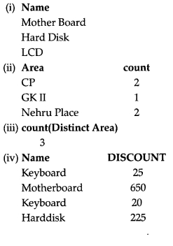

**Question 5:**  
Write SQL queries for:  
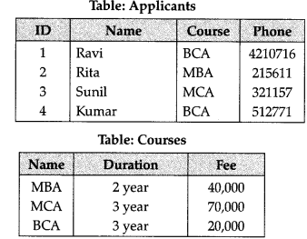

1. To display name, fee, gender, joinyear about the applicants, who have joined before 2010.
2. To display names of applicants, who are playing fee more than 30000.
3. To display names of all applicants in ascending order of their joinyear.
4. To display the year and the total number of applicants joined in each YEAR from the table APPLICANTS.
5. To display the C_ID (i.e., CourselD) and the number of applicants registered in the course from the APPLICANTS and table.
6. To display the applicant’s name with their respective course’s name from the tables APPLICANTS and COURSES.
7. Give the output of following SQL statements:
   * SELECT Name, Joinyear FROM APPLI­CANTS  
     WHERE GENDER=’F’ and C_ID=’A02′;
   * SELECT MIN (Joinyear) FROM  
     APPLICANTS  
     WHERE Gender=’m’;
   * SELECT AVG (Fee) FROM APPLICANTS  
     WHERE C_ID=’A0T OR C_ID=’A05′;
   * SELECT SUM- (Fee), C_ID FROM C_ ID  
     GROUP BY C_ID  
     HAVING COUNT(*)=2;

**Answer:**

1. SELECT NAME,FEE,GENDER,JOINYEAR  
   FROM APPLICANTS  
   WHERE J OINYE AR <2010
2. SELECT NAME FROM APPLICANTS WHERE FEE >30000
3. SELECT NAME FROM APPLICANTS ORDERBY JOINYEAR ASC
4. SELECT YEAR,       COUNT]*)       FROM  
   APPLICANTS GROUP BY YEAR;
5. SELECT C_ID,         COUNT]*)       FROM  
   APPLICANTS, COURSES GROUP BY ID  
   WHERE APPLICANTS.C_ID=COURSES. C_ID
6. SELECT NAME,COURSE           FROM  
   APPLICANTS, COURSES  
   WHERE APPLICANTS. C_ID=COURSES. C_ID
   * Avisha 2009
   * 2009
   * 67
   * 55000 A01

**Question 6:**  
Write SQL queries for (a) to (g) and write the output for the SQL queries mentioned shown in (hi) to (h4) parts on the basis of table ITEMS and TRADERS :  
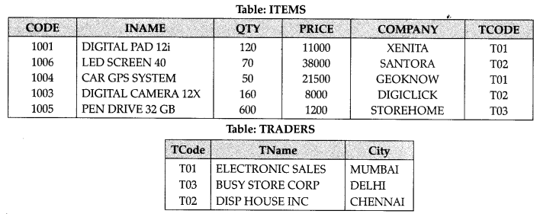

1. To display the details of all the items in ascending order of item names (i.e., INAME).
2. To display item name and price of all those items, whose price is in the range of 10000 and 22000 (both values inclusive).
3. To display the number of items, which are traded by each trader. The expected output of this query should be:
4. To display the price, item name and quantity (i.e., qty) of those items which have quantity more than 150.
5. To display the names of those traders, who are either from DELHI or from MUMBAI.
6. To display the names of the companies and the names of the items in descending order of company names.
7. Obtain the outputs of the following SQL queries based on the data given in tables ITEMS and TRADERS above.
   * SELECT MAX (PRICE), MIN (PRICE) FROM ITEMS;
   * SELECT PRICE*QTY  
     FROM ITEMS WHERE CODE-1004;
   * SELECT DISTINCT TCODE FROM ITEMS;
   * SELECT INAME, TNAME FROM ITEMS I, TRADERS T WHERE I.TCODE=T.TCODE AND QTY< 100;

**Answer:**

1. SELECT INAME FROM ITEMS ORDER BY  
   INAME ASC;
2. SELECT INAME, PRICE FROM ITEMS WHERE PRICE => 10000 AND PRICE =< 22000; (c) SELECT TCODE, COUNT (CODE) FROM ITEMS GROUP BY TCODE;
3. SELECT PRICE, INAME, QTY FROM ITEMS WHERE (QTY> 150);
4. SELECT TNAME FROM TRADERS WHERE (CITY = “DELHI”) OR (CITY = “MUMBAI”)
5. SELECT COMPANY, INAME FROM ITEMS  
   ORDER BY COMPANY DESC;
6. (hi) 38000  
   1200  
   (h2)1075000  
   (h3)T01  
   T02  
   TO3  
   (h4) LED SCREEN 40 DISP HOUSE INC CAR GPS SYSTEM ELECTRONICS SALES

**Question 7:**Write SQL queries for (a) to (f) and write the outputs for the SQL queries mentioned shown in (gl) to (g4) parts on the basis of tables PRODUCTS and SUPPLIERS

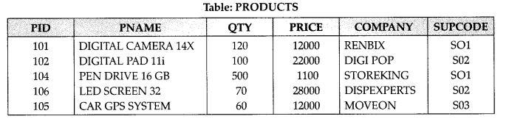

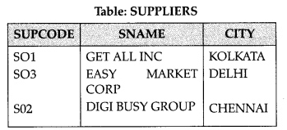

1. To display the details of all the products in ascending order of product names (i.e., PNAME).
2. To display product name and price of all those products, whose price is in the range of 10000 and 15000 (both values inclusive).
3. To display the number of products, which are supplied by each suplier. i.e., the expected output should be;
   * S01    2
   * S02   2
   * S03   1
4. To display the price, product name and quantity (i.e., qty) of those products which have quantity more thhn 100.
5. To display the names of those suppliers, who are either from DELHI or from CHENNAI.
6. To display the name of the companies and the name of the products in descending order of company names.
7. Obtain the outputs of the following SQL queries based on the data given in tables PRODUCTS and SUPPLIERS above.
   * SELECT DISTINCT SUPCODE FROM PRODUCTS;
   * SELEC MAX (PRICE), MIN (PRICE) FROM PRODUCTS;
   * SELECT PRICE*QTY  
     FROM PRODUCTS WHERE PID = 104; (g4)
   * SELECT PNAME, SNAME  
     FROM PRODUCTS P, SUPPLIERS S WHERE E SUPCODE = S. SUPCODE  
     AND QTY>100;

**Answer:**

1. SELECT * FROM PRODUCTS ORDER BY PNAME ASC;
2. SELECT PNAME, PRICE FROM PRODUCTS WHERE ((PRICE => 10000) AND (PRICE = < 15000));
3. SELECT SUPCODE, COUNT (PID) FROM PRODUCTS GROUP BY SUPCODE;
4. SELECT PRICE, PNAME, QTY FROM PRODUCTS WHERE (QTY > 100);
5. SELECT SNAME FROM SUPPLIERS WHERE ((CITY = “DELHI”) OR (CITY = “CHENNAI”));
6. SELECT COMPANY, PNAME FROM PRO-DUCTS ORDER BY COMPANY DESC; 4
7. SOI1  
   (gl)s02       s03  
   (g2) 28000  
   1100  
   (g3) 550000  
   (g4) PNAME                                      SNAME Vi  
   DIGITAL CAMERA 14 X                GETALL INC  
   PENDRIVE16 GB                            GETALL INC

**Question 8:**  
Consider the following tables CARDEN and CUSTOMER and answer (b) and (c) parts of this question:  
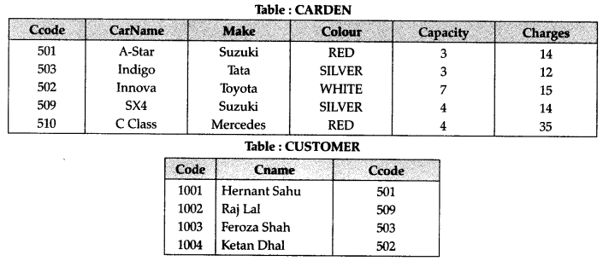

1. Give a suitable example of a table with sample data and illustrate Primary and Alternate Keys in it.
2. Write SQL commands for the following statements:
   * To display the names of all the silver coloured cars.
   * To display names of car, make and capacity of cars in descending order of their sitting capacity.
   * To display the highest charges at which a vehicle can be hired from CARDEN.
   * To display the customer name and the corresponding name of the cars hired by them.
3. Give the output of the following SQL queries:
   * SELECT COUNT(DISTINCT Make) FROM CARDEN;
   * SELECT MAX(Charges), MIN (Charges) FROM CARDEN;
   * SELECT COUNTS), Make FROM CARDEN;

**Answer:**

1. Primary Key of CARDEN = Ccode CARDEN  
   Alternate Key = CarName:  
   Primary key of Customer = Code  
   Alternate Key of Customer = Cname 2
2. SELECT CarName From CARDEN  
   WHERE Color = “SILVER”;
3. SELECT CarName, Make, Capacity From  
   CARDEN ORDER BY Capacity DESC;
4. SELECT MAX(Charges) Frm CARDEN;
5. ELECT Cname, CarName From  
   CARDEN, CUSTOMER WHERE  
   CARDEN. Ccode = CUSTOMER. Ccode;
6. (i) 4  
   (ii) MAX(Charges)        MIN (Charges)  
   35                                           112  
   (iii) 5  
   (iv)  SX4  
   C Class

**Question 9:**  
Consider the following tables CABHUB and CUSTOMER and answer (b) and (c) parts of this question :  
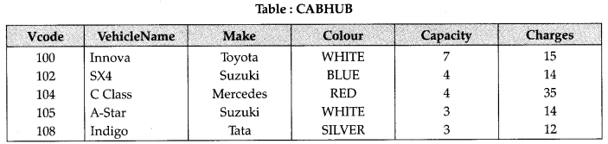

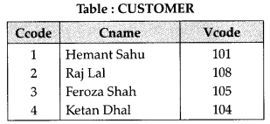

1. Give a suitable example of a table with sample data and illustrate Primary and Candidate Keys in it.
2. Write SQL commands for the following statements:
   * To display the names of all the white coloured vehicles.
   * To display name of vehicle name and capacity of vehicles in ascending order of their sitting capacity.
   * To display the highest charges at which a vehicle can be hired from CABHUB.
   * To display the customer name and the corresponding name of the vehicle hired by them.
3. Give the output of the following SQL queries :
   * SELECT COUNT(DISTINCT Make) FROM CABHUB;
   * SELECT MAX(Charges), MIN(Charges)
   * FROM CABHUB;
   * SELECT COUNT (*) Make FROM CABHUB;
   * SELECT Vehicle FROM CABHUB WHERE Capacity=4;

**Answer:**

1. Primary key of CABHUB = Vcode alternate key of CABHUB = Vehicle Name. Primary key of Customer = Ccode Alternate Key of CUSTOMER = Cname.
2. (i) SELECT VehicleName FROM CABHUB  
   WHERE Colour = “WHITE”;
3. SELECT VehicleName, capacity From CABHUB ORDER BY Capacity ASC;
4. SELECT MAX(Charges) FROM CABHUB;
5. SELECT Cname,VehicleName FROM CABHUB, CUSTOMER WHERE CUSTO­MER. Vcode=CABHUB. Vcode;
6. (i) 4  
   (ii) MAX(Charges)        MIN (Charges)  
   35                                           12  
   (iii) 5  
   (iv)  SX4  
   C Class

**Question 10:**  
Consider the following tables EMPLOYEE and DEPARTMENT and answer (a) and (b) parts of this question.  
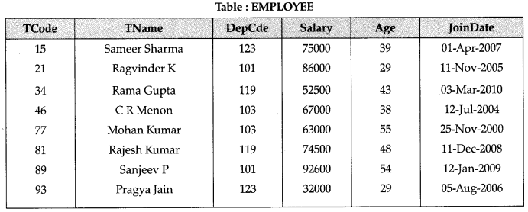

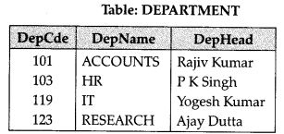

1. **Write SQL commands for the following statements:**
   * To display all DepName along with the DepCde in descending order of DepCde.
   * To display the average age of Employees in DepCde as 103.
   * To display the name of DepHead of the Employee named “Sanjeev P”
   * To display the details of all employees who has joined before 2007 from EMPL­OYEE table.
2. **Give the output of the following SQL queries:**
   * SELECT COUNT (DISTINCT DepCde) FROM EMPLOYEE;
   * SELECT MAX(JoinDate), MIN (JointDate) FROM EMPLOYEE;
   * SELECT TName, DepHead FROM EMPLOYEE E, DEPARTMENT D  
     WHERE E.DepCde = D.DepCde;
   * SELECT COUNT (*) FROM EMPLOYEE WHERE Salary > 60000 AND Age > 30;

**Answer:**

**(a)**

1. SELECT DEPNAME, DEPARTME-NT.  
   DepCde FROM EMPLOYEE, DEPART­  
   MENT WHERE EMPLOYEE. DepCDE=  
   DEPARTMENT.  DepCde Order by DepCde DESC;
2. Select AVG (Age) from EMPLOYEE WH­ERE DepCde=”103″;
3. SELECT DeptHead FROM DEPART  
   MENT WHERE Employee. TName=  
   “Sanjeev P” AND          EMPLOYEE. DepCde  
   = DEPARTMENT. DepCde;
4. SELECT * from EMPLOYEE WHERE  
   joinDate<’01-JAN-2007′;

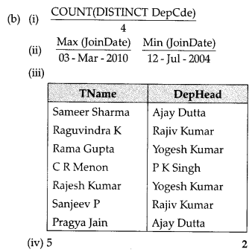

**Question 11:**  
Consider the following tables WORKER and PAYLEVEL and answer (a) and (b) parts of this question:  
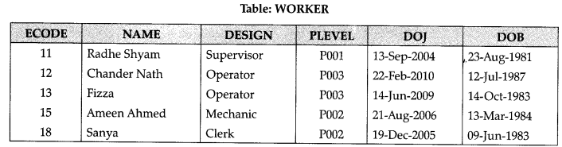

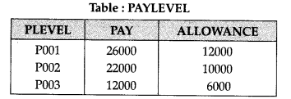

**(a) Write SQL commands for the following statements:**

1. To display the name of all Workers in descending order of DOB.
2. To display NAME and DESIGN of those Workers, whose PLEVEL is either P001 or
3. To display the content of all the workers table, whose DOB is in between ’19-JAN- 1984′ and ’18-JAN-1987′.
4. To add a new row with the following:  
   19, ‘DayaKishore’, ‘Operator’, ‘P003′, ’19- Sep-2008’, ‘ll-Jul-1984’

**(b) Give the output of the following SQL queries :**

1. SELECT COUNT (PLEVEL), PLEVEL FROM WORKER GROUP BY PLEVEL;
2. SELECT MAX(DOB), MIN(DOJ) FROM WORKER;
3. SELECT Name,PAY FROM WORKER  
   W,PAYLEVEL P WHERE W.LEVEL=  
   P.PLEVEL AND W.ECODE<13;
4. SELECT  PLEVEL, PAYLEVEL  
   WHERE PLEVEL=”POO3″;

**Answer:**

**(a)**

1. SELECT NAME FROM WORKER  
   ORDER BY DOBDESC;
2. SELECT NAME, DESIGN FROM WORKER WHERE PLEVEL=”POOO1″ OR  
   PLEVEL=”POO2″;
3. SELECT * FROM  WORKER WHERE  
   DOB BETWEEN ’19-JAN-1984 AND ’18-JAN-1987′;
4. INSERT INTO WORKER VALUES (19,”DayaKISHORE”, “oPERATOR”, “P0003”,’19-Sep-2008′,’11-Jul-1984′)’

**(b)**  
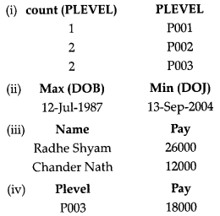

**Question 12:**Consider the following tables EMPLOYEE and SALGRADE and answer (b) and (c) parts of this question:

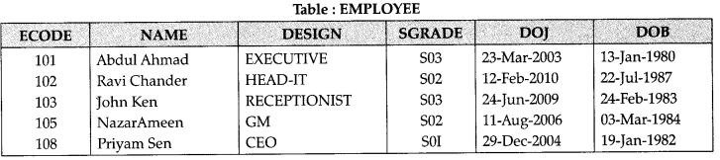

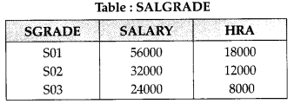

**(a) What do you understand by Selection and Projection operations in relational algebra ?**  
**(b) Write SQL commands for the following statements :**

1. To display the details of all EMPLOYEES in descending order of DOJ.
2. To display NAME and DESIGN of those EMPLOYEES, whose SAL-GRADE is either S02 or S03.
3. TO display the content Of all the EMPLOYEES table, whose DOJ is in between ’09-Feb-2006′ and ’08-Aug-2009′.
4. To add a new row with the following:  
   109, ‘HarishRoy’, ‘HEAD-IT’, ‘SOX, ’09-  
   Sep-2007′, ’21-Apr-1983’

**(c) Give the output of the following SQL  queries :**

1. SELECT COUNT(SGRADE), SGRADE  
   FROM EMPLOYEE GROUP BY  
   SGRADE;
2. SELECT MIN(DOB), MAX(DOJ) FROM EMPLOYEE;
3. SELECT NAME, SALARY FROM  
   EMPLOYEE E, SAL-GRADE S WHERE  
   E.SGRADE=    S.SGRADE AND E.ECODE<103′;
4. SELECT  SGRADE, SALARY +HRA FROM SALGRADE WHERE SGRADE =SGRADE=’S02;’

**Answer:**  
**Projection(ff):** In relational algebra, a projection is a unary operafion. The result of such  projecion is defined as the set obtained when  the components Of the tuple R are restriceted  to the set {a1……an}. It discards (or excludes)  the other attributes.  
Selection(σ): In relational algebra, a selection  
is a unary operation written as  πaθb(R) or σaθυ (R) where:

1. a and b are attribute names.
2. p is a binary operation in the set.
3. v is a value constant.
4. R is a relation.

The selection (R) selects all those tuples in R for which 9 holds between the a and the b

**(b)**

1. SELECT FROM EMPLOYEE ORDER BY DOJ DESC;
2. SELECT NAME, DESIGN FROM EMPLOYEE WHERE SGRADE – “S02” OR SGRADE = “SO3;
3. SELECT * FROM EMPLOYEE WHERE DOJ BETWEEN ’09-FEB-2006′ AND ’08- AUG -200%
4. INSERT INTO EMPLOYEE VALUES(109, “HARSH RAY”, “HEAD-IT.S02”, ’09-SEP-  
   2007′, ’21-APR-1983′);

important-questions-for-class-12-computer-science-python-structured-query-language-12i  
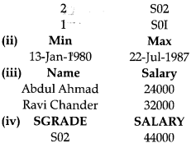

**Question 13:**  
Consider the following tables GAMES and PLAYER and answer (b) and (c) parts of this question :  
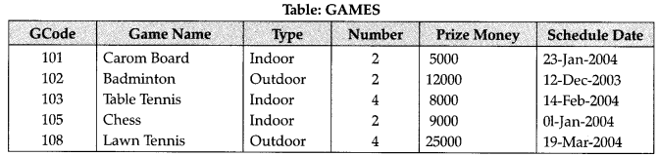

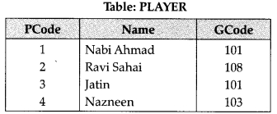

**(a)What do you understand by primary key and candidate keys ?  
(b)Write SQL commands for the following state­ments:**

1. To display the name of all GAMES with their GCodes.
2. To display details of those GAMES which are having PrizeMoney more than 7000.
3. To display the content of the GAMES table in ascending order of Schedule Date.
4. To display sum of PrizeMoney for each type of GAMES.

**(c) Give the output of the following SQL queries:**

1. SELECT COUNT(DISTINCT Number) FROM GAMES;
2. SELECT MAX(ScheduleDate), MIN(Sche- duleDate) FROM GAMES
3. SELECT Name, GameName FROM GAMES G, PLAYER P  
   WHERE (G.Gcode=PGcode AND G.Pri- zeMoney>10000);
4. SELECT DISTINCT Geode FROM PLA­YER;

**Answer:**

**(a)** An attribute or set of attributes which are used to identify a tuple uniquely is known as a primary key. If a table has more than one such attributes which identify a tuple uniquely than all such attributes are known as candidate keys.

**(b)**

1. SELECT GameName, GCode FROM GAMES;
2. SELECT * FROM Games WHERE PrizeMoney >7000;
3. SELECT * FROM Games ORDER BY ScheduleDate;
4. SELECT SUM(Pnzemoney) FROM Games GROUPBY Type;

**(c)**

1. 2
2. 19-Mar-2004 12-Dec-2003
3. Ravi Sahai Lawn Tennis
4. 101 108 103

**Question 14:**  
Consider the following tables ACTIVITY and COACH and answer (a) and (b) parts of this question :  
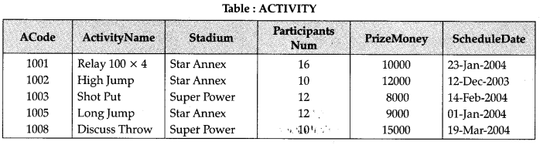

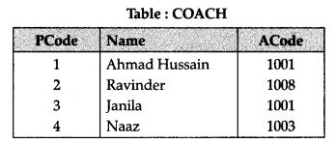

**(a) Write SQL commands for the following statements:**

1. To display the names of all activities with their Acodes in descending order.
2. To display sum of PrizeMoney for the Activities played in each of the Stadium separately.
3. To display the coach’s name and acodes in ascending order of Acode from the table Coach.
4. To display the content of the Activity table whose schedule date earlier than 01-01-2004 in ascending order of Participants Num.

**(b) Give the output of the following SQL queries:**

1. SELECT COUNT (DISTINCT Participants Num) FROM ACTIVITY;
2. SELECT MAX (Schedule Date), Min (Schedule Date) FROM ACTIVITY;
3. SELECT Name, Activity Name FROM ACTIVITY A, COACH C  
   WHERE A.Acode=C.Acode AND A.Parti- cipants Num=10;
4. SELECT DISTINCT Acode FROM COACH;

**Answer:**

**(a)**

1. SELECT Acodes, ActivityName FROM ACTIVITY ORDER BY ACode DESC;
2. SELECT SUM(PrizeMoney) FROM ACTIVITY GROUP BY Stadium;
3. SELECT Name, Acode FROM COACH ORDER BY Acode;
4. SELECT * FROM ACTIVITY WHERE SchduleDate < ’01-Jan-2004′ ORDER BY ParticipantsNum;

**(b)**

1. 3
2. 12-Dec-2003 19-Mar-2004
3. Ravinder Discuss Throw
4. 1001  
   1008  
   1003

**Question 15:**Consider the following tables RESORT and OWNEDBY and answer (a) and (b) parts of this question:  
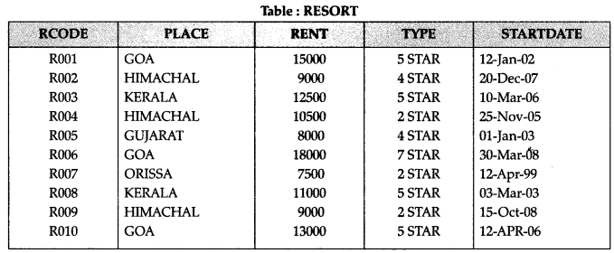

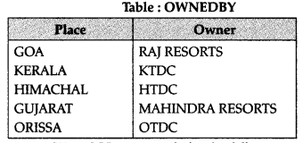

**(a)Write SQL commands for the following state­ments:**

1. To display the RCODE and PLACE of all ‘5 STAR’ resorts in the alphabetical order of the place from table RESORT.
2. To display the maximum and minimum rent for each type of resort from table RESORT.
3. To display the details of all resorts which are started after 31-DEC-05 from table RESORT.
4. Display the OWNER of all ‘5 STAR’ resorts from tables RESORT and OWNEDBY.

**(b)Give output for the following SQL queries:**

1. SELECT MIN(RENT) FROM RESORT Where PLACE = ‘KERALA’;
2. SELECT TYPE, START DATE  FROM RESORT Where TYPE ‘2 STAR’  
   ORDERBY STARTDATE,
3. SELECT PLACE, OWNER  FROM  
   OWNEDBY Where PLACE LIKE “%A”;
4. SELECT RCODE, RENT FROM RESORT,  OWNEDBY WHERE (RESORT PLACE= OWNEDBY. PLACE AND TYPE = ‘3 STAR’);

**Answer:  
 (a)**

1. SELECT RCODE, PLACE FROM RESORT mere TYPE = “5 STAR” ORDER  
   BY PLACE;
2. SELECr MAX (RENT), MIN (RENT) FROM RESORT GROUP BY TYPE;
3. SELECT FROM RESORT WHERE OSWAAL (BSE Question Bank. COMPUTER SCIENCE – PYTHON, STARTDATE > ’31-DEC-05′;
4. SELECT OWNER FROM RESOR OWNEDBY B WHERE (A.TYPE  START’ AND A.PLACE B.PLACE);

**(b)**

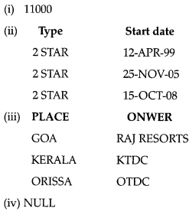

**Question 16:**Consider the following tables STORE and SUPPLIERS and answer (a) and (b) parts of this question:  
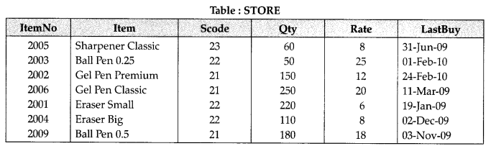

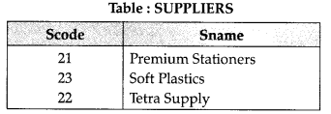

**(a) Write SQL commands for the following state­ments:**

1. To display details of all the items in the STORE table in ascending order of LastBuy.
2. To display ItemNo and Item name of those items from STORE table whose Rate is more than 15 Rupees.
3. To display the details of those items whose supplier code (Scode) is 22 or Quantity in Store (Qty) is more than 110 from the table Store.
4. To display minimum Rate of items for each supplier individually as per Scode from the table STORE.

**(b) Give the output of the following SQL queries:**

1. SELECT COUNT(DISTINCT Scode) FROM STORE;
2. SELECT Rate* Qty FROM STORE WHERE ItemNo=2004;
3. SELECT Item, Sname FROM STORE S, Suppliers P
4. WHERE S.Scode=PScode AND ItemNo=2006;
5. SELECT MAX(LastBuy) FROM STORE;

**Answer:**

(a)

1. SELECT * FROM STORE ORDER BY LastBuy ASC;
2. SELECT ItemNo, Item FROM STORE WHERE Rate > 15;
3. SELECT * FROM STORE WHERE (Scode = ’22’ OR Qty >’110′);
4. SELECT Sname, MIN(Rate) FROM STORE, SUPPLIERS WHERE STORE. Scode = SUPPLIERS.Scode GROUP BY Sname;

(b)

1. 3
2. 880
3. **Item**                                                   **Sname**  
   Gel Pen Classic                          Premium Stationers
4. 24-Feb-10

**Question 17:**Consider the following tables STOCK and DEALERS and answer (a) and (b) parts of this question:  
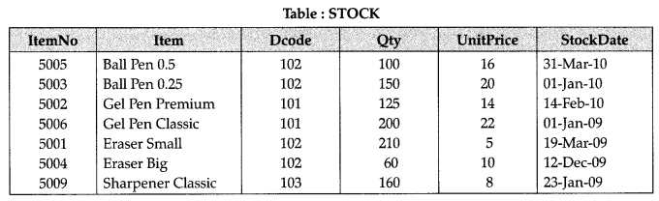

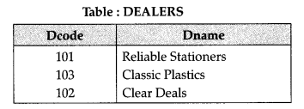

**(a)Write SQL commands for the following  statements:**

1. To display the details of all Items in the STOCK table in ascending order of StockDate.
2. To display ItemNo and Item name of those items from STOCK table whose UnitPrice is more than Rupees 10.
3. To display the details of those items whose dealer code (Dcode) is 102 or quantity in STOCK (Qty) is more than 100 from the table Stock.
4. To display maximum UnitPrice of items for each dealer individually as per Dcode from the table STOCK.

**(b)Give the output of the following SQL queries:**

1. SELECT COUNT(DISTINCT Dcode)  
   FROM STOCK;
2. SELECT Qty* UnitPrice FROM STOCK WHERE ItemNo=5006;
3. SELECT Item, Dname FROM STOCK S, Dealers D WHERE S.Dcode=D.Dcode AND ItemNo = 5004;
4. SELECT MIN (StockDate) FROM STOCK;

**Answer:**

**(a)**

1. SELECT*FROM STOCK ORDER BY StockDate;
2. SELECT Item No, Item FROM STOCK WHERE UnitPrice >10;
3. SELECT *FROM DEALERS, STOCK  
   WHERE         (DEALERS.Dcode=”102″OR STOCK.Qty >100 and DEALERS. DCODE = STOCK.DCODE);
4. SELECT MAX (Unitprice) FROM DEALERS, STOCK ORDER BY STOCK. Dcode WHERE DEALERS.Dcode = STOCK.Dcode;

**(b)**

1. 3
2. 4400
3. **Item**                         **Dname**  
   Eraser Big               Clear Deals
4. 01-Jan-09

[Python](https://www.cbsetuts.com/important-questions-class-12-computer-science-python/)[NCERT Solutions](http://www.learncbse.in/ncert-solutions-2/)[English](http://www.learncbse.in/ncert-solutions-for-class-12-english/)[Hindi](http://www.learncbse.in/ncert-solutions-class-12-hindi-core/)[Humanities](http://www.learncbse.in/cbse-class-12-humanities/)[Commerce](http://www.learncbse.in/cbse-class-12-commerce/)[Science](http://www.learncbse.in/cbse-class-12-science/)

Primary Sidebar

[](https://www.learncbse.in/ncert-exemplar-problems-solutions/) [](https://www.learncbse.in/previous-year-question-paper/) [](https://goo.gl/tt7H2u) [](https://www.learncbse.in/chapterwise-previous-years-questions-pyqs-solutions/)

* [The Summer Of The Beautiful White Horse Answers](https://www.cbsetuts.com/ncert-solutions-for-class-11-english-snapshots-chapter-1/)
* [Job Application Letter class 12 Samples](https://www.cbsetuts.com/cbse-class-12-english-letter-writing-letters-application-jobs/)
* [Science Lab Manual Class 9](https://www.cbsetuts.com/ncert-class-9-science-lab-manual/)
* [Letter to The Editor Class 12 Samples](https://www.cbsetuts.com/cbse-class-12-english-letter-writing-letters-editor/)
* [Unseen Passage For Class 6 Answers](https://www.cbsetuts.com/cbse-class-6-english-reading-skills-reading-iii/)
* [NCERT Solutions for Class 12 Hindi Core](https://www.cbsetuts.com/ncert-solutions-for-class-12-hindi-core-kaavy-bhaag-aatm-parichay-ek-geet/)
* [Invitation and Replies Class 12 Examples](https://www.cbsetuts.com/cbse-class-12-english-writing-skills-invitation-reply/)
* [Advertisement Writing Class 11 Examples](https://www.cbsetuts.com/cbse-class-11-english-writting-grammar-advertisements/)
* [Lab Manual Class 10 Science](https://www.cbsetuts.com/ncert-class-10-science-lab-manual/)

RECENT POSTS

* [CBSE Class 12 Business Studies Case Studies – Marketing](https://www.cbsetuts.com/cbse-class-12-business-studies-case-studies-marketing/)
* [NCERT Solutions for Class 12 Economics](https://www.cbsetuts.com/ncert-solutions-for-class-12-economics/)
* [CBSE Sample Papers for Class 10 English Communicative Set 5 with Solutions](https://www.cbsetuts.com/cbse-sample-papers-for-class-10-english-communicative-set-5/)
* [CBSE Sample Papers for Class 10 English Communicative Set 4 with Solutions](https://www.cbsetuts.com/cbse-sample-papers-for-class-10-english-communicative-set-4/)
* [CBSE Sample Papers for Class 10 English Communicative Set 3 with Solutions](https://www.cbsetuts.com/cbse-sample-papers-for-class-10-english-communicative-set-3/)
* [CBSE Sample Papers for Class 10 English Communicative Set 2 with Solutions](https://www.cbsetuts.com/cbse-sample-papers-for-class-10-english-communicative-set-2/)
* [NEET Chemistry Notes Redox Reactions-Concepts of Oxidation and Reduction](https://www.cbsetuts.com/neet-chemistry-notes-redox-reactions-concepts-oxidation-reduction/)
* [NEET Chemistry Notes Chemical Equilibrium-Acids and Bases](https://www.cbsetuts.com/neet-chemistry-notes-chemical-equilibrium-acids-bases/)
* [NEET Chemistry Notes Redox Reactions – Oxidation Number](https://www.cbsetuts.com/neet-chemistry-notes-redox-reactions-oxidation-number/)
* [CBSE Sample Papers for Class 10 English Communicative Set 1 with Solutions](https://www.cbsetuts.com/cbse-sample-papers-for-class-10-english-communicative-set-1/)
* [CBSE Notes for Class 10 Foundation of Information Technology – Introduction to XML](https://www.cbsetuts.com/cbse-notes-class-10-foundation-information-technology-introduction-xml/)
* [NEET Chemistry Notes Chemical Equilibrium – Equilibrium State](https://www.cbsetuts.com/neet-chemistry-notes-chemical-equilibrium-equilibrium-state/)
* [NEET Chemistry Notes Chemical Thermodynamics-Thermodynamics](https://www.cbsetuts.com/neet-chemistry-notes-chemical-thermodynamics-thermodynamics/)
* [NEET Chemistry Notes Chemical Thermodynamics – Second Law of Thermodynamics](https://www.cbsetuts.com/neet-chemistry-notes-chemical-thermodynamics-second-law-thermodynamics/)
* [NEET Chemistry Notes Chemical Thermodynamics – Hess’s Law of Constant Heat Summation](https://www.cbsetuts.com/neet-chemistry-notes-chemical-thermodynamics-hesss-law-constant-heat-summation/)

Footer

MATHS NCERT SOLUTIONS

|  |
| --- |
| [NCERT Solutions for Class 12 Maths](https://www.cbsetuts.com/ncert-solutions-for-class-12-maths/) |
| [NCERT Solutions for Class 11 Maths](https://www.cbsetuts.com/ncert-solutions-for-class-11-maths/) |
| [NCERT Solutions for Class 10 Maths](https://www.cbsetuts.com/ncert-solutions-for-class-10-maths/) |
| [NCERT Solutions for Class 9 Maths](https://www.cbsetuts.com/ncert-solutions-for-class-9-maths/) |
| [NCERT Solutions for Class 8 Maths](https://www.cbsetuts.com/ncert-solutions-for-class-8-maths/) |
| [NCERT Solutions for Class 7 Maths](https://www.cbsetuts.com/ncert-solutions-for-class-7-maths/) |
| [NCERT Solutions for Class 6 Maths](https://www.cbsetuts.com/ncert-solutions-for-class-6-maths/) |

SCIENCE NCERT SOLUTIONS

|  |  |
| --- | --- |
| [NCERT Solutions for Class 12 Physics](https://www.cbsetuts.com/ncert-solutions-for-class-12-physics/) | |
| [NCERT Solutions for Class 12 Chemistry](https://www.cbsetuts.com/ncert-solutions-for-class-12-chemistry/) | |
| [NCERT Solutions for Class 11 Physics](https://www.cbsetuts.com/ncert-solutions-for-class-11-physics/) | |
| [NCERT Solutions for Class 11 Chemistry](https://www.cbsetuts.com/ncert-solutions-for-class-11-chemistry/) | |
| [NCERT Solutions for Class 10 Science](https://www.cbsetuts.com/ncert-solutions-for-class-10-science/) | |
| [NCERT Solutions for Class 9 Science](https://www.cbsetuts.com/ncert-solutions-for-class-9-science/) | |
| [NCERT Solutions for Class 7 Science](https://www.cbsetuts.com/ncert-solutions-for-class-7-science/) | |
| [MCQ Questions](https://www.cbsetuts.com/mcq-questions/) | [NCERT Solutions](https://www.cbsetuts.com/ncert-solutions/) |
| [CBSE Sample Papers](https://www.cbsetuts.com/cbse-sample-papers/) |  |
| [NCERT Exemplar Solutions](https://www.cbsetuts.com/ncert-exemplar-problems-solutions/) | [LCM and GCF Calculator](https://lcmgcf.com/) |
| [TS Grewal Accountancy Class 12 Solutions](https://www.cbsetuts.com/ts-grewals-double-entry-book-keeping-class-12-solutions-accountancy/) |  |
| [TS Grewal Accountancy Class 11 Solutions](https://www.cbsetuts.com/ts-grewal-solutions-class-11-accountancy/) |  |